**A**

**PROJECT REPORT**

**ON**

**"Electrostatic Spraying System”**

**SUBMITTED BY**

**Dere Priyal Nivrutti (B190133042)**

**Divekar Sahil Kiran (B190133048)**

**Gampawar Varad Sanjay (B190133052)**

**Under the Guidance of**

**Dr. S. S. Morade**



**DEPARTMENT OF ELECTRONICS & TELECOMMUNICATION   
 ENGINEERING**

**K. K. WAGH INSTITUTE OF ENGINEERING EDUCATION &   
 RESEARCH, NASHIK.**

**SAVITRIBAI PHULE PUNE UNIVERSITY**

**2023-2024**

**Dissertation Approval Sheet**

This is to certify that the project work titled **“Electrostatic Spraying System”**, has been submitted in partial fulfillment of the Bachelor’s degree in Electronics and Telecommunication during the academic year of 2023-2024 by following students:

Dere Priyal Nivrutti (B190133042)

Divekar Sahil Kiran (B190133048)

Gampawar Varad Sanjay (B190133052)

This project confirms to the standards laid down by the Savitribai Phule Pune University and has been completed in satisfactory manner as a partial fulfillment for the Bachelor’s degree in Electronics and Telecommunication Engineering.

**External Examiner Internal Guide Head of Department**    **( Dr. S. S. Morade) (Prof. Dr. D. M. Chandwadkar)**

**ACKNOWLEDGEMENT**

With all respect and gratitude, we would like to thank all the people who have helped us directly or indirectly for this project work.

We express our heartily gratitude towards our guide Dr. S. S. Morade to complete this project work on **“Electrostatic Spraying System”** his ideas and direction gave us moral boost up to complete this project work.

We would like to thank Prof. Dr. S. A. Patil (Ugale) senior faculty and Prof. Dr. D. M. Chandwadkar HOD of Electronics and Telecommunication Department and also Prof. Dr. K. N. Nandurkar Principal, K. K. Wagh Institute of Engineering Education and Research, and all the teaching and non – teaching staff members of department for providing necessary information and required resources timely.

We are ending this acknowledgement with deep indebtedness to our friends and every person who have helped us to complete the manuscript.

1. Dere Priyal Nivrutti (B190133042)

2. Divekar Sahil Kiran (B190133048)

3. Gampawar Varad Sanjay (B190133052)

**Plagiarism Certificate**

This is to certify that the project work titled **“Electrostatic Spraying System”**, is a part of project work carried out by “Priyal Nivrutti Dere, Sahil Kiran Divekar, Varad Sanjay Gampawar”under the guidance of Dr. S. S. Morade at K. K. Wagh Institute of Engineering Education and Research, Nashik, in the partial fulfillment of the requirements for Bachelor’s degree in Electronics and Telecommunication Engineering. To the best of our knowledge, the work included in this report is an original work carried out by us independently. The percentage of plagiarism is_______. The results of the project work in part or whole have not been submitted to any other Institute/University for the award of any degree.

Dere Priyal Nivrutti (B190133042)

Divekar Sahil Kiran (B190133048)

Gampawar Varad Sanjay (190133052)

**ABSTRACT**

Electrostatic spraying systems have engaged as a booming technology in the field of agricultural, industrial, and healthcare sectors due to their ability to provide efficient, uniform, and precise coating or distribution of liquids onto target surfaces.

As agriculture requires sustainable solutions, the Electrostatic Pesticide Spraying System plays important role. This project will examine its role in reducing pesticide application, benefiting farmers and the environment. The Electrostatic Pesticide Sprayer System represents a revolutionary approach to pesticide spraying in agriculture. This project explore its fundamentals, potential advantages, and practical applications. By utilizing electrostatic charges to ensure thorough coverage and adherence, this system minimizes pesticide needs, enhances insect management, and reduces environmental impact.

Electrostatic spraying uses electrostatic principles to control droplet application. Positively charged pesticide droplets are attracted to negatively charged plant surfaces, increasing attraction and minimizing waste. Electrostatic spraying system battery use as a supply source to provide 9 volt 0.6 Ah to voltage multiplier. Main function of voltage multiplier is to multiply 9 volt DC to high voltage DC up to 30 KV. Positive terminal of this high DC supply is directly given to the nozzle of system and negative terminal is grounded, due to positive terminal the spray particle which travels through nozzle generates positive charge. Then the electrostatic field is form between spray nozzle and object spray covers the both side of object front side as well as back side. Using traditional spraying methods frequently results in an uneven distribution of pesticide liquid, which makes pest control ineffectual. Because of the electrostatic charge, electrostatic spraying devices increase the effectiveness of pest management by confirming uniform spread of droplets and better attraction to plant surfaces.

**Index**

Sr

No. Chapter No. Page No.

1. Introduction

1.1. Introduction 1

1.2. Need of Project 2

1.3. Target Community of Project 3

1.4. Scope of Project 4

1.5. Objective of Project 5

1.6. Gantt chart 7

2. Literature Survey 8

3. Design Methodology Page No.

3.1 System requirements and Specifications 13

3.2 Block diagram and description 14

3.3 Hardware design 16

3.4 Hardware implementation 21

3.5 Software Design 24

3.6 PCB Design and Layout 25

4. Test procedure and Results 26

5. Conclusion and Future scope 28

References

**List of Figures**

|  |  |  |  |
| --- | --- | --- | --- |
| **Sr. No.** | **Fig. No.** | **Content** | **Page No.** |
| 1 | 1.1 | Gantt chart of project completion | 7 |
| 2 | 3.1 | Block Diagram of Electrostatic Spraying System | 13 |
| 3 | 3.2 | Voltage Multiplier circuit diagram | 15 |
| 4 | 3.3 | DC-DC Step up transformer | 17 |
| 5 | 3.4 | Drop size test for various voltage | 18 |
| 6 | 3.5 | Charge to mass ratio for various voltage | 19 |
| 7 | 3.6 | Circuit implementation | 20 |
| 8 | 3.7 | Deployment of circuit on sprayer | 21 |
| 9 | 3.8 | Implementation of circuit on sprayer handle | 22 |
| 10 | 3.9 | Circuit simulation | 23 |
| 11 | 3.10 | PCB implementation | 24 |
| 12 | 3.11 | Test Result | 25 |

**CHAPTER 1**

**INTRODUCTION**

* 1. **Introduction**

Modern agriculture largely relies on the use of pesticides to protect crops from harmful pests and diseases. However, traditional spraying methods often result in inefficiency, excessive use of chemicals, environmental damage and high health risks for farmers. Electrostatic spray technology has emerged as a solution to these challenges. The purpose of this project is to provide an overview of electrostatic pesticide spray systems and discuss their benefits, applications and importance in agriculture.

Conventional spraying techniques using air-based sprays or hydraulic nozzles result in uneven distribution of droplets, increasing the risk of pesticide movement in random directions and the use of larger amounts of pesticide. In contrast, electrostatic spraying uses electrostatic principles to control the spreading of droplets. Positively charged pesticide droplets are attracted to negatively charged plant surfaces, increasing attachment and minimizing waste. This project describes the components and operation of electrostatic spray systems, highlighting benefits such as reduced pesticide use, environmental impact and improved crop protection. Various agricultural applications such as greenhouse cultivation and orchard are also being explored.

As agriculture requires sustainable solutions, the electrostatic pesticide spraying system plays an important role. This project explores its role in reducing pesticide use, which benefits farmers and the environment. The electrostatic pesticide spraying system represents a revolutionary approach to pesticide spraying in agriculture. This project explores its reasons, potential benefits and practical applications. Using electrostatic charges to ensure thorough coverage and adhesion, this system minimizes the need for pesticides, improves insect control and reduces environmental impact.

The high voltage charger charges the insecticide. Typically, when droplets begin to form, an electrode placed near the atomizing nozzle induces a charge. Depending on which direction the direct current is applied, a strong electrostatic field can transfer a positive or negative charge. Imagine a droplet that is negatively charged. It now has its own field that guides it to land on electrically neutral surfaces. As the drop approaches the object, the electrons moving on its surface are directed and repel the negative charge of the drop. This creates a relatively positive charge on the surface of the object, which attracts the droplet.

* 1. **Need of Project**

In order to meet the demand of todays agriculture need for more economical, ecologically friendly, and efficient pesticide application techniques, electrostatic spraying systems are adopted. These technologies are important for enhancing sustainable pest control methods and guaranteeing the long-term usable for agricultural produce since they overcome the drawbacks of conventional spraying methods.

**Improved performance:**

Using traditional spraying methods frequently results in an uneven distribution of pesticide liquid, which makes pest control ineffectual. Because of the electrostatic charge, electrostatic spraying devices increase the effectiveness of pest management by confirming uniform spread of droplets and better attraction to plant surfaces.

**Less pesticide requirement:**

Traditional spraying methods usually require more concentrations of pesticides to obtain sufficient coverage, resulting in excess use of chemicals. Electrostatic spraying methods creates charged droplets that are attracted to plant surfaces, minimizing the required pesticide volume while maintaining effectiveness. This decrease in chemical use and reduces expenses while also having a less effect on the environment.

**Beneficial to environment:**

Pesticide movement, in which chemicals sprayed are carried by the wind to unexpected places, increases serious environmental hazards, including damage to crops that are not intended targets, animals, and water systems. By carefully directing droplets toward the desired target, electrostatic spraying systems reduce the risk of environmental harm and ecological damage.

**Farmers Safety:**

Direct contact with pesticides and exposure to chemical substance are two ways that traditional pesticide spraying techniques put farmers health at risk. For agricultural workers, electrostatic spraying system provide a more organised application technique that reduces exposure risk and helps better working conditions.

**Sustainability:**

As the importance of sustainable farming rises, so does the need for technology that reduce environmental harm while protecting productivity. By decreasing the amount of chemicals used, controlling environmental damage, and improving overall pest management efficiency, electrostatic spraying systems support sustainability guidelines.

**1.3. Target Community of Project**

The target community for electrostatic spraying systems primarily includes:

**Farmers :**

The main users of electrostatic spraying system are agricultural farmers. Their crops need to be protected from pests and diseases, and this technologies give farmers a more effective and efficient way to do so. With proper application and better droplet attraction, farmers can gain improved coverage, leading to thorough pest management and healthier crops. With better pest control, farmers can expect high-quality crops that fullfil market standards and provides best prices. Electrostatic spraying systems helps in reducing pest and disease outbreaks, resulting in healthier crops.

**Agricultural Consultants:**

Professionals involved in agricultural management, such as agronomists, crop consultants, and agricultural engineers, are also part of the target community. They may recommend and provide guidance on the use and implementation of electrostatic spraying systems to optimize pesticide management.

**Sanitation Services:**

To effectively spray disinfectants and cleaning liquid in commercial and residential buildings, cleaning businesses might make use of electrostatic spraying systems. By ensuring complete surface coverage, this method reduces the possibility of spread of diesease.

**Industrial Coating and Painting:**

Electrostatic spraying systems are used to apply coatings, paints, and finishes to a variety of surfaces in industries including metal fabrication, aerospace, and automobile manufacture. Better finishes are achieved because of the onestroke coverage and attraction provided by the electrostatic charge.

**Maintenance of Public Area:**

Electrostatic spraying systems can be used by municipalities and facility management firms to carry out regular cleaning of public spaces including parks, playgrounds, and leisure zones. By doing this, public places are kept hygienic and clean.

**Governmental Organizations:**

The target community also includes organizations in charge of policing the use of pesticides and guaranteeing the safety of the environment.

**1.4. Scope of Project**

**Agriculture:**

Using electrostatic sprayers, insecticides, herbicides, and fungicides are applied efficiently in agriculture. By increasing coverage and reducing wastage, they improve disease and pest control.

**Forest Management:**

Under controlled circumstances, herbicides and other chemicals can be sprayed via electrostatic spraying to manage unnecessary species and undergrowth in forests.

**Nurseries:**

Growth regulators, fertilizers, and pesticides can be applied to plants precisely and uniformly with electrostatic sprayers, which promotes healthy growth. These tools are helpful in greenhouse and nursery operations.

**Public health:**

Electrostatic sprayers are used to administer insecticides in mosquito control programs efficiently and prevent the spread of diseases like the West Nile virus and Zika.

**Automotive and Aerospace:**

Electrostatic spray guns are used in these industries to apply paint and finishes to cars and aircraft. Because the charged particles stick to surfaces more readily, a more equal finish is achieved.

**Furniture and Metal Finishing:**

Electrostatic spraying is a technique that applies a coating to metals and furniture to obtain a high-quality and efficient finish.

**Electronics Production: PCB Coating:**

Using electrostatic sprayers, printed circuit boards (PCBs) are coated to protect sensitive electronic components from environmental contaminants.

**Textile Sector:**

Electrostatic systems can be used in the textile sector to apply dye evenly, increasing color consistency and requiring less dye.

**Food Industry:**

Antimicrobial solutions or coatings can be electrostatically sprayed onto food products to increase food safety and increase shelf life.

**1.5. Objective of Project**

**Improved performance:**

The purpose of electrostatic spraying systems is to increase productivity and efficiency when applying pesticides. These technologies assist farmers in regulate their operations and allocating resources more wisely, which eventually increases profitability and competitiveness by covering more regions in less time and with less resources.

**Benefits Safety:**

Another goal of electrostatic spraying systems is safety, especially for the environment and farmers. These solutions tries to reduce risks and create safer working environments for agricultural workers by avoiding exposure to pesticides and chemical usage.

**Uniqueness:**

These systems strive to satisfy the various demands of farmers and applicators in various agricultural situations by providing flexibility in nozzle configurations, spray settings, and application techniques.

**Uniform Application:**

Applying liquids, such as insecticides, uniformly across the target surface is another goal. Compared to traditional spraying techniques, electrostatic spraying systems produce more uniform coverage and distribution by using electrostatic forces to create uniformly charged droplets that are drawn to surfaces.

**Reduced Environmental Impact and Drift:** The goal of electrostatic spraying systems is to reduce the amount of pesticide drift, which happens when sprayed droplets wind up in unwanted places. These devices aid in lowering off-target deposition and environmental contamination by guiding charged droplets toward the target surface, encouraging environmental stewardship and regulatory compliance.

**Enhanced Pest Control:**

Improving crop pest and disease management is one of the main goals of electrostatic spraying systems in agriculture. These solutions are designed to reduce insect damage and increase crop yields by guaranteeing more efficient pesticide droplet coverage and adherence to plant surfaces.

**Decreased Chemical Usage:**

By applying chemicals more effectively and efficiently, electrostatic spraying systems aim to maximize the use of insecticides and other chemicals. These systems try to limit environmental effect and reduce farmers' input costs by lowering the amount of chemical required to achieve desired results.

**1.6 Ghantt Chart**

|  |  |  |  |  |  |  |  |  |  |
| --- | --- | --- | --- | --- | --- | --- | --- | --- | --- |
| **Sr. No.** | **Activity** | **Aug-23** | **Sep-23** | **Oct-23** | **Nov-23** | **Dec-23** | **Jan-24** | **Feb-24** | **April 24** |
| 1 | Topic Selection & literature survey |  |  |  |  |  |  |  |  |
| 2 | Finalization of project specifications |  |  |  |  |  |  |  |  |
| 3 | Design of Circuit |  |  |  |  |  |  |  |  |
| 4 | Design of Simulation |  |  |  |  |  |  |  |  |
| 6 | Documentation- Sem1 |  |  |  |  |  |  |  |  |
| 7 | Project Assembly |  |  |  |  |  |  |  |  |
| 8 | Testing |  |  |  |  |  |  |  |  |
| 9 | Documentation- Sem2 |  |  |  |  |  |  |  |  |

Figure 1.1 Gantt chart of project completion

**CHAPTER 2**

**LITERATURE REVIEW**

S. E. LAW ,et al stated that, The new technology that has been disclosed refers to liquid electrostatic spraying systems, particularly to an improved spray-charging nozzle system which is more dependable, consistent, safe, and energy-efficient for continuous operation in challenging industrial and agricultural applications. The invention provides these objectives through: a) Controlling how any electrostatic fields interact with the droplet charging electric-induction field that is used for the nozzle, involving either partial or total isolation of the former fields; b) Retaining the charge-induction electric field at the droplet-formation region by avoiding or decreasing charge loss from the induction electrode in all directions; c) Guarding against accidental overcurrent harm to  device d) Enabling quick, easy, and effortless nozzle cleaning and inspection under challenging field circumstances [1].

Patel, et al. In this paper author acknowledges that , In India, the need for innovative chemical application sprayers for the spraying of pesticides on agriculture is essential. The purpose of this research is to design and develop an induction-charging-based air-assisted electrostatic nozzle, with particular focus on the agricultural and topographical conditions of India. A brand-new, improved air-assisted electrostatic nozzle has been created for modest farms. This nozzle is sustainable, portable, very efficient, and reduces the dangers to human health and pesticide usage. Combining an air-assisted nozzle with an induction-based electrostatic charging mechanism is known as an air-assisted electrostatic nozzle system. Reusable DC batteries can be charged to several kilovolts within the house using the nozzle itself to generate the portable high voltage power supply. [2].

S. E. law , et al. stated that, The use of electrically charged nozzles has become essential for improving droplet dispersion control, which decreases drifting and uses fewer spray chemicals. Using a 6V DC battery input, the high voltage generator was constructed in accordance with the Cockcroft-Walton multiplier voltage theory. The goal of creating the self-sprinkling hydrotube was to generate the range of droplets necessary for efficient electrostatic charge induction. At four electrode sites in the spark zone and five electrode potentials , the experimental device's charge-to-mass ratio was measured. Using a Faradays principle, the charge mass ratio of the spray cloud was determined at five different distances from the nozzle tip . At 5 mm from the atomization zone, the electrode voltage potential at 5 kV displayed the highest CMR value of 1.088 mC. It was noted that the designed charging system, at 4 kV and 5 kV, outperformed the commercial system  in CMR from 100 cm to 250 cm distances, with the exception of 50 cm. After evaluating the constructed system's droplet spectrum, it was found that the droplets' sizes ranged from 100 to 200 µm. [3].

Appah S, et al. stated that, Low-surface energy droplets' electrostatic empowering process is methodically disclosed. From its molecular framework, the functioning of nano-bio fluids is approached. A detailed explanation of the breakage and absorption dynamics of the atomization medium is provided. Discovered are methods, tools, and infrastructure for enhancing high contact friction. [4].

Yamane S, et al. says that, With the goal of lowering the cost of producing vegetables by reducing the amount of agricultural chemicals used and the amount of time spent on controlling pests, researchers have created an electrostatic pesticide spraying system for moderately concentrated, significant volume applications. A high velocity hydraulic nozzle is enclosed by an outer ring induction charging electrode in the electrostatic spray charging device . Spray droplets with a high flow rate  were produced by a hollow-cone nozzle, and their charge-to-mass ratio ranged from -0.30 to -0.45 mC/kg. The electrode did not discharge or discharge any electricity. According to field studies, this boom-type sprayer required 30% less pesticide to be applied than the traditional approach. [5].

Shrimpton JS, et al. talks about, An internal sharp electrode current source, maintained at a high electrical potential, has been used to study the dynamics and governing processes involved in a charge injection electrostatic atomization technique for insulating liquids. Superior spray coating/deposition applications and combustion mechanisms are two potential uses for this technology, which is suited to highly insulating liquids like hydrocarbon oils and oil-based solutions. Different forms of electrical breakdown define the subcritical and supercritical flow rates of atomizer operation. An insulating failure of the liquid hydrocarbon itself, which takes place inside the atomizer, limits the critical flow range. This process does not result in finely atomized sprays, although being interesting to comprehend the basic principles of electrohydromechanics. The highest spray particular charge in the supercritical flow zone is limited by a partial release in the gas surrounding the liquid jet as it exits the nozzle, which is a characteristic of atomization performance in this regime. In this scenario, precisely atomized sprays are feasible and the maximum flow rate limit is not electrically limited. It has been observed that at increased nozzle exit speeds and smaller entrance diameters, there is an increase in the greatest spray specific charge feasible in the supercritical domain. These two elements work in concert to boost the charged liquid jet's destabilisation, which results in finely atomized and evenly distributed sprays of insulating liquids as the charged liquid stream bursts from the aperture at higher velocities due to enhanced airflow turbulence. [6].

Mamidi V, et al. stated that, To increase the effectiveness of pesticide deposition, electrostatic force fields were used in the construction of the electrostatic swirl nozzle. The electrostatic hand pressure knapsack sprayer with an induction charge design provided the smallest distance between the liquid sheet and the induction electrode. At ambient circumstances (T=20±2 °C, RH=57±3%), the experiments were carried out in an air atmosphere with a liquid feed rate of 340 ml/min, applied voltage ranging from 0 V to +5 kV, and applied pressure of 30 psi. With a volume median diameter of 100 µm, a charging efficiency of 0.37 mC/kg has been measured at 3.3 kV. The consistency of accumulation in the target's buried parts was an increment of 2.0–2.5 fold. [7].

Seong-Ho Son, et al. author proposes a fixed component model for resonant converters' Cockcroft-Walton voltage multiplier (CWVM) circuits. The CWVM circuits are transformed into two lumped capacitors and perfect rectifiers using the suggested model. By doing this, the analysis error brought on by the oscillation between the CWVM capacitors and resonant inductors can be decreased. Additionally, by using the lumped capacitors as resonant capacitors, the total amount of converter elements can be decreased. PSIM simulation is used to show the suggested model's correctness and applicability. The design and execution of an LCC resonant converter, appropriate for high step-up applications, are described for the practical application of the suggested model. To validate the suggested works, the 5kW and 10kV LCC resonant converter experimental results are displayed. [8].

Sang Hyeon Park, et al. paper presents a voltage multiplier design that combines elements of a Dickson charge pump with a Cockcroft-Walton multiplier. When the number of multiplier stages in the Cockcroft-Walton structure rises, there is a noticeable drop in output voltage under load. The reason for this is that every coupling capacitor has a series connection. By interconnecting all of the capacitors in parallel, the Dickson charge pump minimises this problem. However, the final multiplier stage will experience significant capacitor voltage stress as a result of this solution. The suggested hybrid arrangement achieves low output voltage drop and low capacitor voltage stress simultaneously by arranging some capacitors in series and others in parallel. We create a model that forecasts the outcomes of composite multipliers and test it through experiments. [9].

Y. Berkovich, et al. states that, An innovative modification of a DC-DC converter with a high voltage ratio is proposed. An input boost converter, a bridge commutator, and a Dickson voltage multiplier make up the converter. One of the circuit's distinguishing characteristics is its large voltage gain. One of the primary benefits of the circuit in the continuous current mode (CCM) is its almost rigid external characteristic. The absence of active power losses throughout the capacitor recharging process makes this possible. The low required capacitance of the voltage multiplier capacitors is another advantage of the proposed scheme. A comprehensive analysis of the recommended converters has been produced. The results of the theoretical analysis are verified by the MATLAB/SIMULINK simulation. A lab prototype with 200W of output power has been utilised to confirm the [10].

Prudente, et al. This paper introduces Application of the voltage multiplier approach to traditional non-isolated dc-dc converters in order to reduce the maximum switch voltage, achieve zero current switching turn-on, and achieve high step-up static gain. In addition to acting as a regenerative clamping circuit, the voltage multiplier minimises the inverse recovery current problem of the diodes, which lowers the layout and EMI generation issues. These features enable high efficiency and high static resistance operation, allowing for the construction of small circuits for situations where isolation is not necessary. For the single-phase and multiphase dc-dc converters, the working concept, the design process, and the useful findings from the implemented prototypes are provided. The single-phase approach was used to test a boost converter for a purpose that needed an output. [11].

D. K. Giles et al. elaborate on the several charging methods available for electrostatic spraying. Direct charging, ionised field charging, and induction charging are these. The coverage on the upper and lower surfaces of plants is superior to that of traditional spraying due to the size of the droplets generated electrostatically. However, the initial costs of electrostatic sprayers remain high, and in certain instances, the droplets are unable to reach the crowns of tall trees. It is imperative to consistently perform accurate calibration of the sprayer and monitor the meteorological conditions when conducting electrostatic spraying [12].

**CHAPTER 3**

**Design Methodology**

**3.1. System Requirement and Specification**

This system has the following specifications: -

Input voltage: 9V 0.6A DC

Droplet Size: 50 micron

Air pressure: 27/30 PSI

Output Voltage: 20 KV

Input Source:

Requirement: battery-operated using a lithium-ion rechargeable battery

Specification: 9V, 0.6Ah battery capacity allows for up to 4 hours of continuous use.

Electrostatic Charging:

Requirement: Electrostatic charge production is necessary for effective droplet deposition.

Specification: 20 kV of output voltage and 90% charging efficiency

Spraying Performance:

Requirement: Equitable coverage and efficient penetration are necessary.

Specification: Distribution of droplet sizes: 50–100 microns Spray pattern: Mist or cone that can be adjusted 0.5-2 litres per minute is the flow rate.

Compatibility:

Compatibility with different pesticide formulations is a requirement.

Specification: Water-soluble concentrations, suspensions, and liquid formulations can all use this. Modifiable parameters for various application scenarios

**3.2 Block Diagram and Description**

This Block diagram explains the working flow of “Electrostatic spraying system”. As shown in block diagram air compressor is used to compress the air , creating high pressure of 30 psi and provide it to pesticide. The main part of this system is Electrostatic supply , it is powered by the 12 v DC supply which is stepped up and multiplied to higher voltage . The step up transformer and voltage multiplier forms a circuit which the gives the high output voltage to the nozzle and then to the liquid droplets.

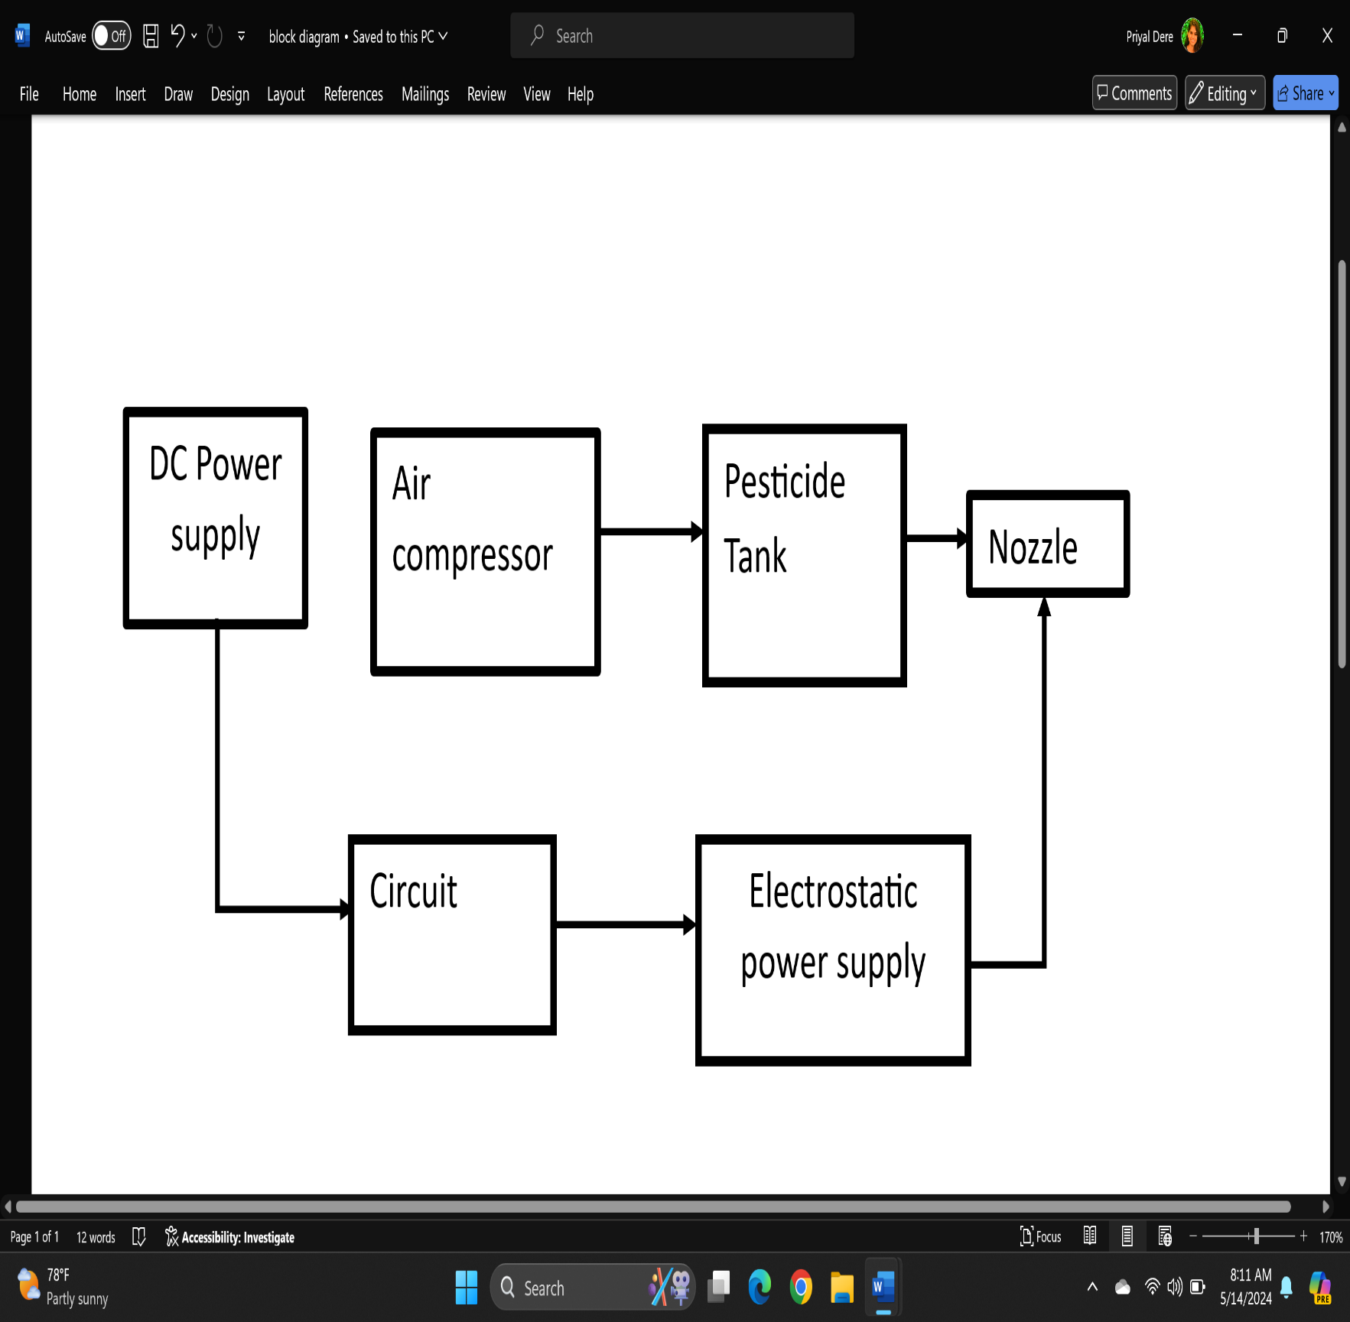

Fig. 3.1 : Block Diagram of Electrostatic Spraying System

**3.2.1.Pesticide tank :**

The pesticide solution that will be sprayed is kept in the pesticide tank. The capacity of pesticide tank may vary , but in this project , tank of 5 liter capacity is used.

**3.2.2.Air Compressor :**

In order to provide the required flow and pressure for the spraying operation, the pump pressurizes the pesticide solution. The pump provides the output of about 30 psi to the system which creates the required pressure in liquid.

**3.3.3.Electrostatic Charging System:**

The system that gives pesticide droplets an electrostatic charge as they exit the nozzles is the core of the electrostatic spraying system. It is made up of multiple parts:

Power Supply

The DC voltage of 12 V is provided to the system using battery

Step up transformer

The 12V input DC is stepped up using the transformer. The DC supply is converted to pulsating DC and then stepped up to 20KV.

Voltage multiplier

It is a capacitor and diode circuit. The capacitor and diodes are connected in series such that at each capacitor diode pair acts as a voltage doubler. Such 3 stage multiplier is used.

**3.2.4. Nozzles :**

The charged pesticide droplets must be sprayed uniformly and under control by the nozzles.

The air-based nozzle is used in the system .

**3.3 Hardware Design**

It is a capacitor and diode circuit. The capacitor and diodes are connected in series such that at each capacitor diode pair acts as a voltage doubler. Such 3 stage multiplier is used.

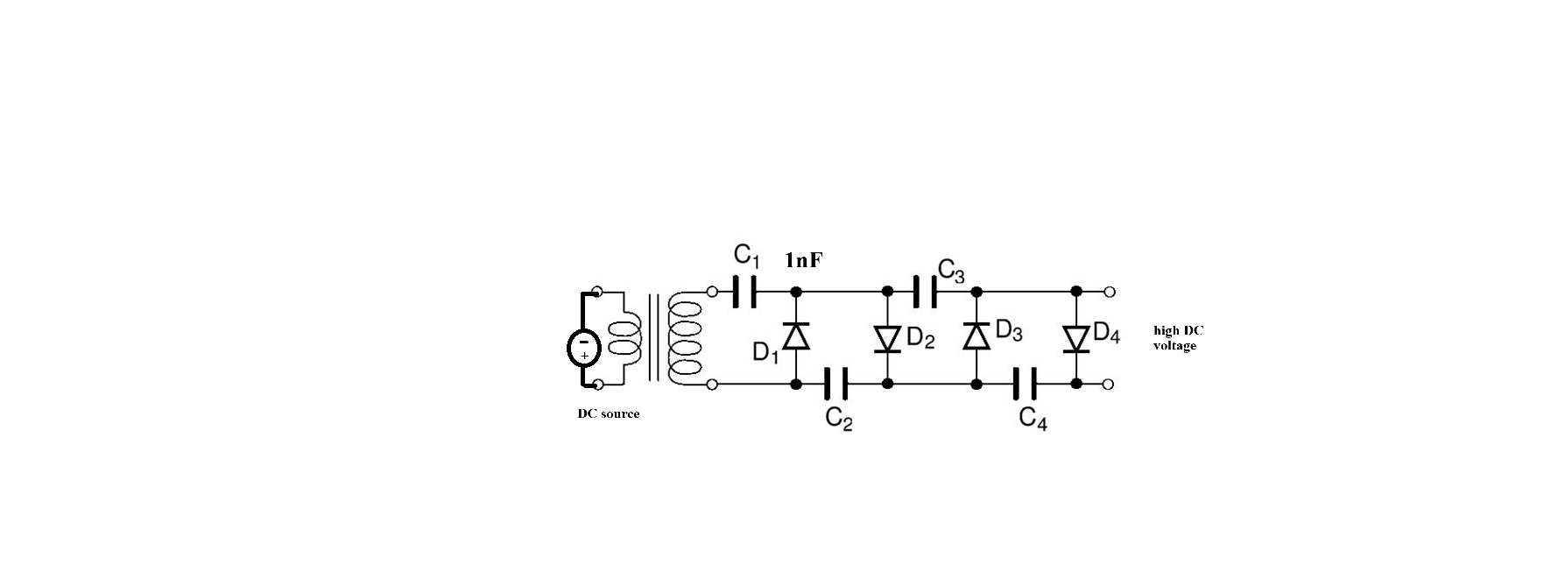

Fig 3.2 Voltage Multiplier circuit diagram

**Selection Criteria:**

Components selection is done according to the values to be measured. Below table shows the values to be measured at circuit input and output side and suitable component to measure particular parameter.

|  |  |  |
| --- | --- | --- |
| **Sr. No.** | **Parameters To Be Measured** | **Ratings** |
| 1 | Input voltage | 9 Volts |
| 2 | Input current | 0.6 A |
| 3 | Output Voltage | 20  KVolts |
| 4 | Output Current | 1 mA |

Table 3.1 Values to Be Measured

**3.3.1 Details of Component**

Capacitors:

Capacitors store and smooth the charge in voltage multiplier circuits. High-voltage, high-capacitance capacitors are used for this project.

Specifications:

Capacitance: 1 nF/30kv.

Voltage Rating: Capacitors should be rated for the maximum expected output voltage. For example, 30KV or more.

Transformer :

The dc/dc step up transformer is designed to supply a output voltage of 5kV and the input voltage 9 V.

Step-up transformers use coils wound around a core to increase voltage from input to output. They are essential to the transmission of power because they raise voltage and decrease losses

Features:

• Low maintenance

• Reduced noise level

• Low temperature rise

The formula used to design a step up transformer is

Where,

• Ns = number of turns in secondary, 36000

• Np = number of turns in primary, 52

• Vs = voltage in secondary

• Vp = voltage in primary, 9V

Vs= (Ns/Np)*Vp

Vs=(36000/52)*9

Vs= 6 KV

For step up transformer Vp<Vs , Np <Ns

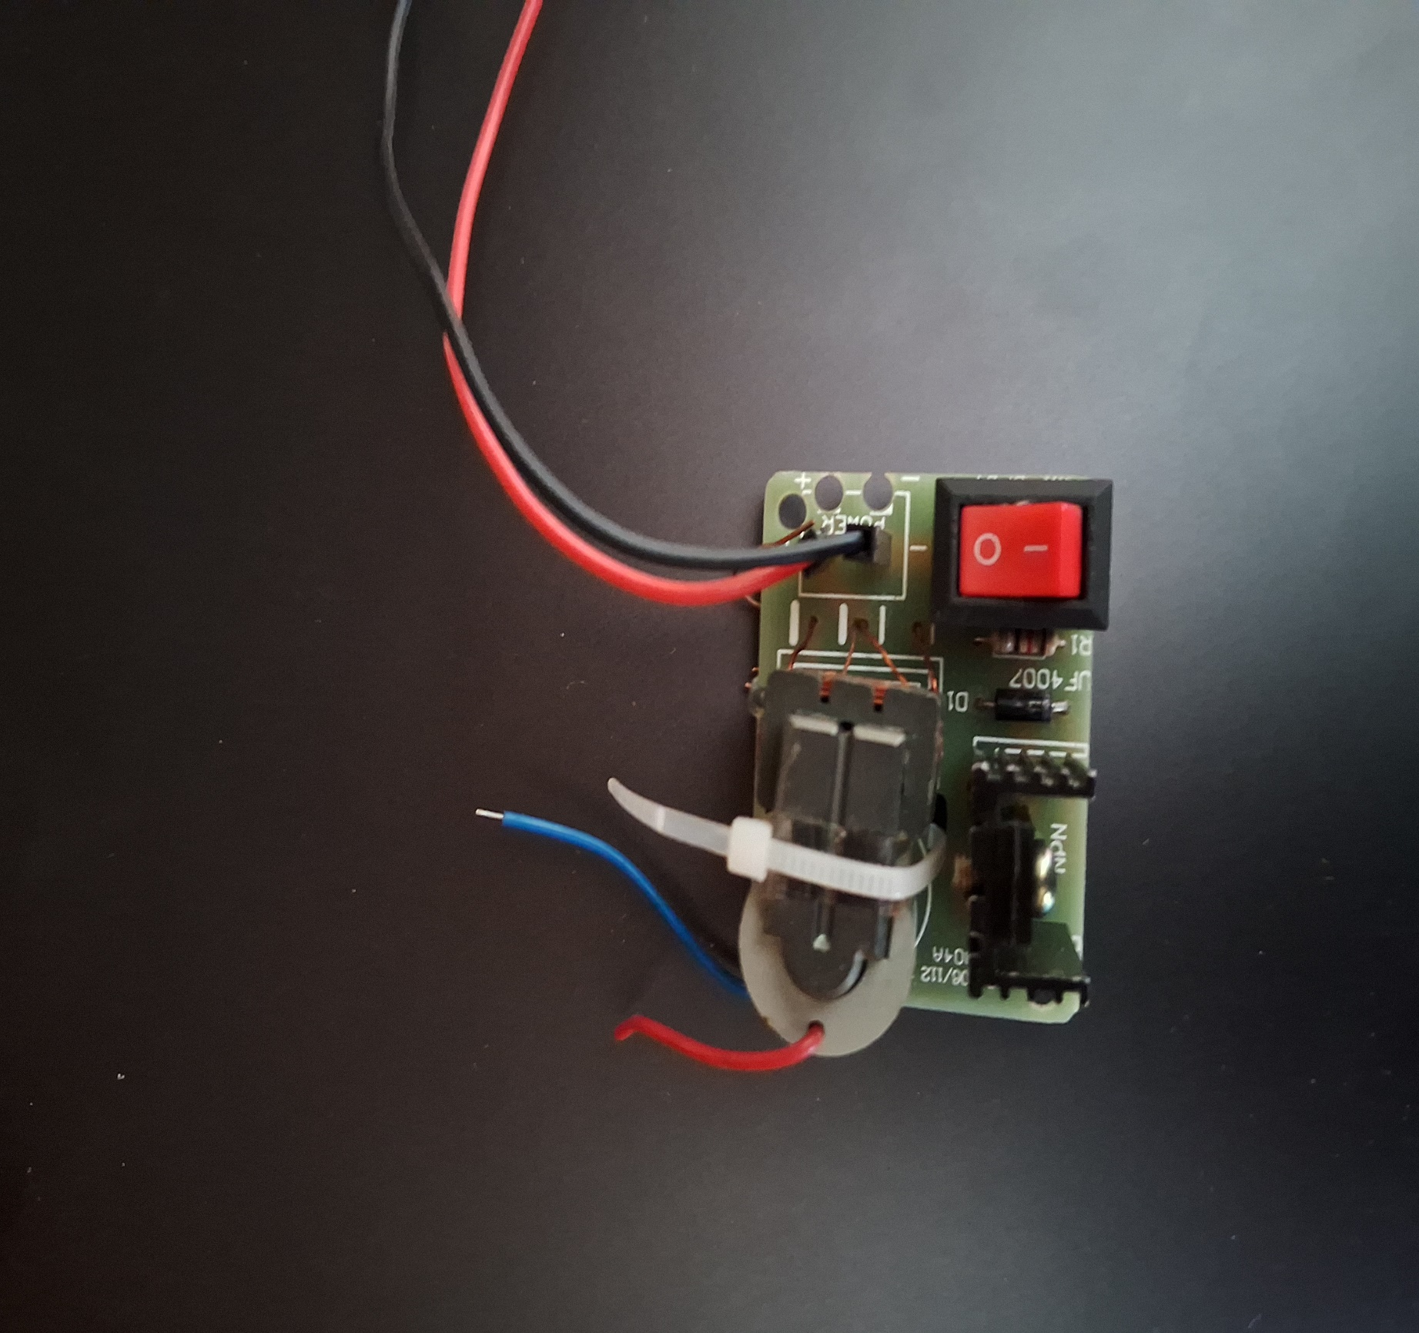

Fig. 3.2 DC-DC Step up transformer

**3.3.2 Droplet size measurement**

It is possible to calculate droplet sizes at various spray angles, charging voltages, and locations. Figure shows a graph that shows droplet sizes at different charging voltages (15 kV and 20 kV) but at the same spray settings and position (15 m from the spray). The VMD is 108.4 μm for non-electrostatic spraying, 96.7 μm at 15 kV charging voltage and 80.6 μm at 20 kV charging voltage for electrostatic spraying. In Figure , a comparison of a and b reveals that b's curve extends in the direction of the small droplets, suggesting that the generation of small droplets is distinct. Consequently, the atomization of droplets can be enhanced by electrostatic spraying. Because of the steeper c curve than the curve of b indicates that as charging voltages increased, droplet size became more uniform.

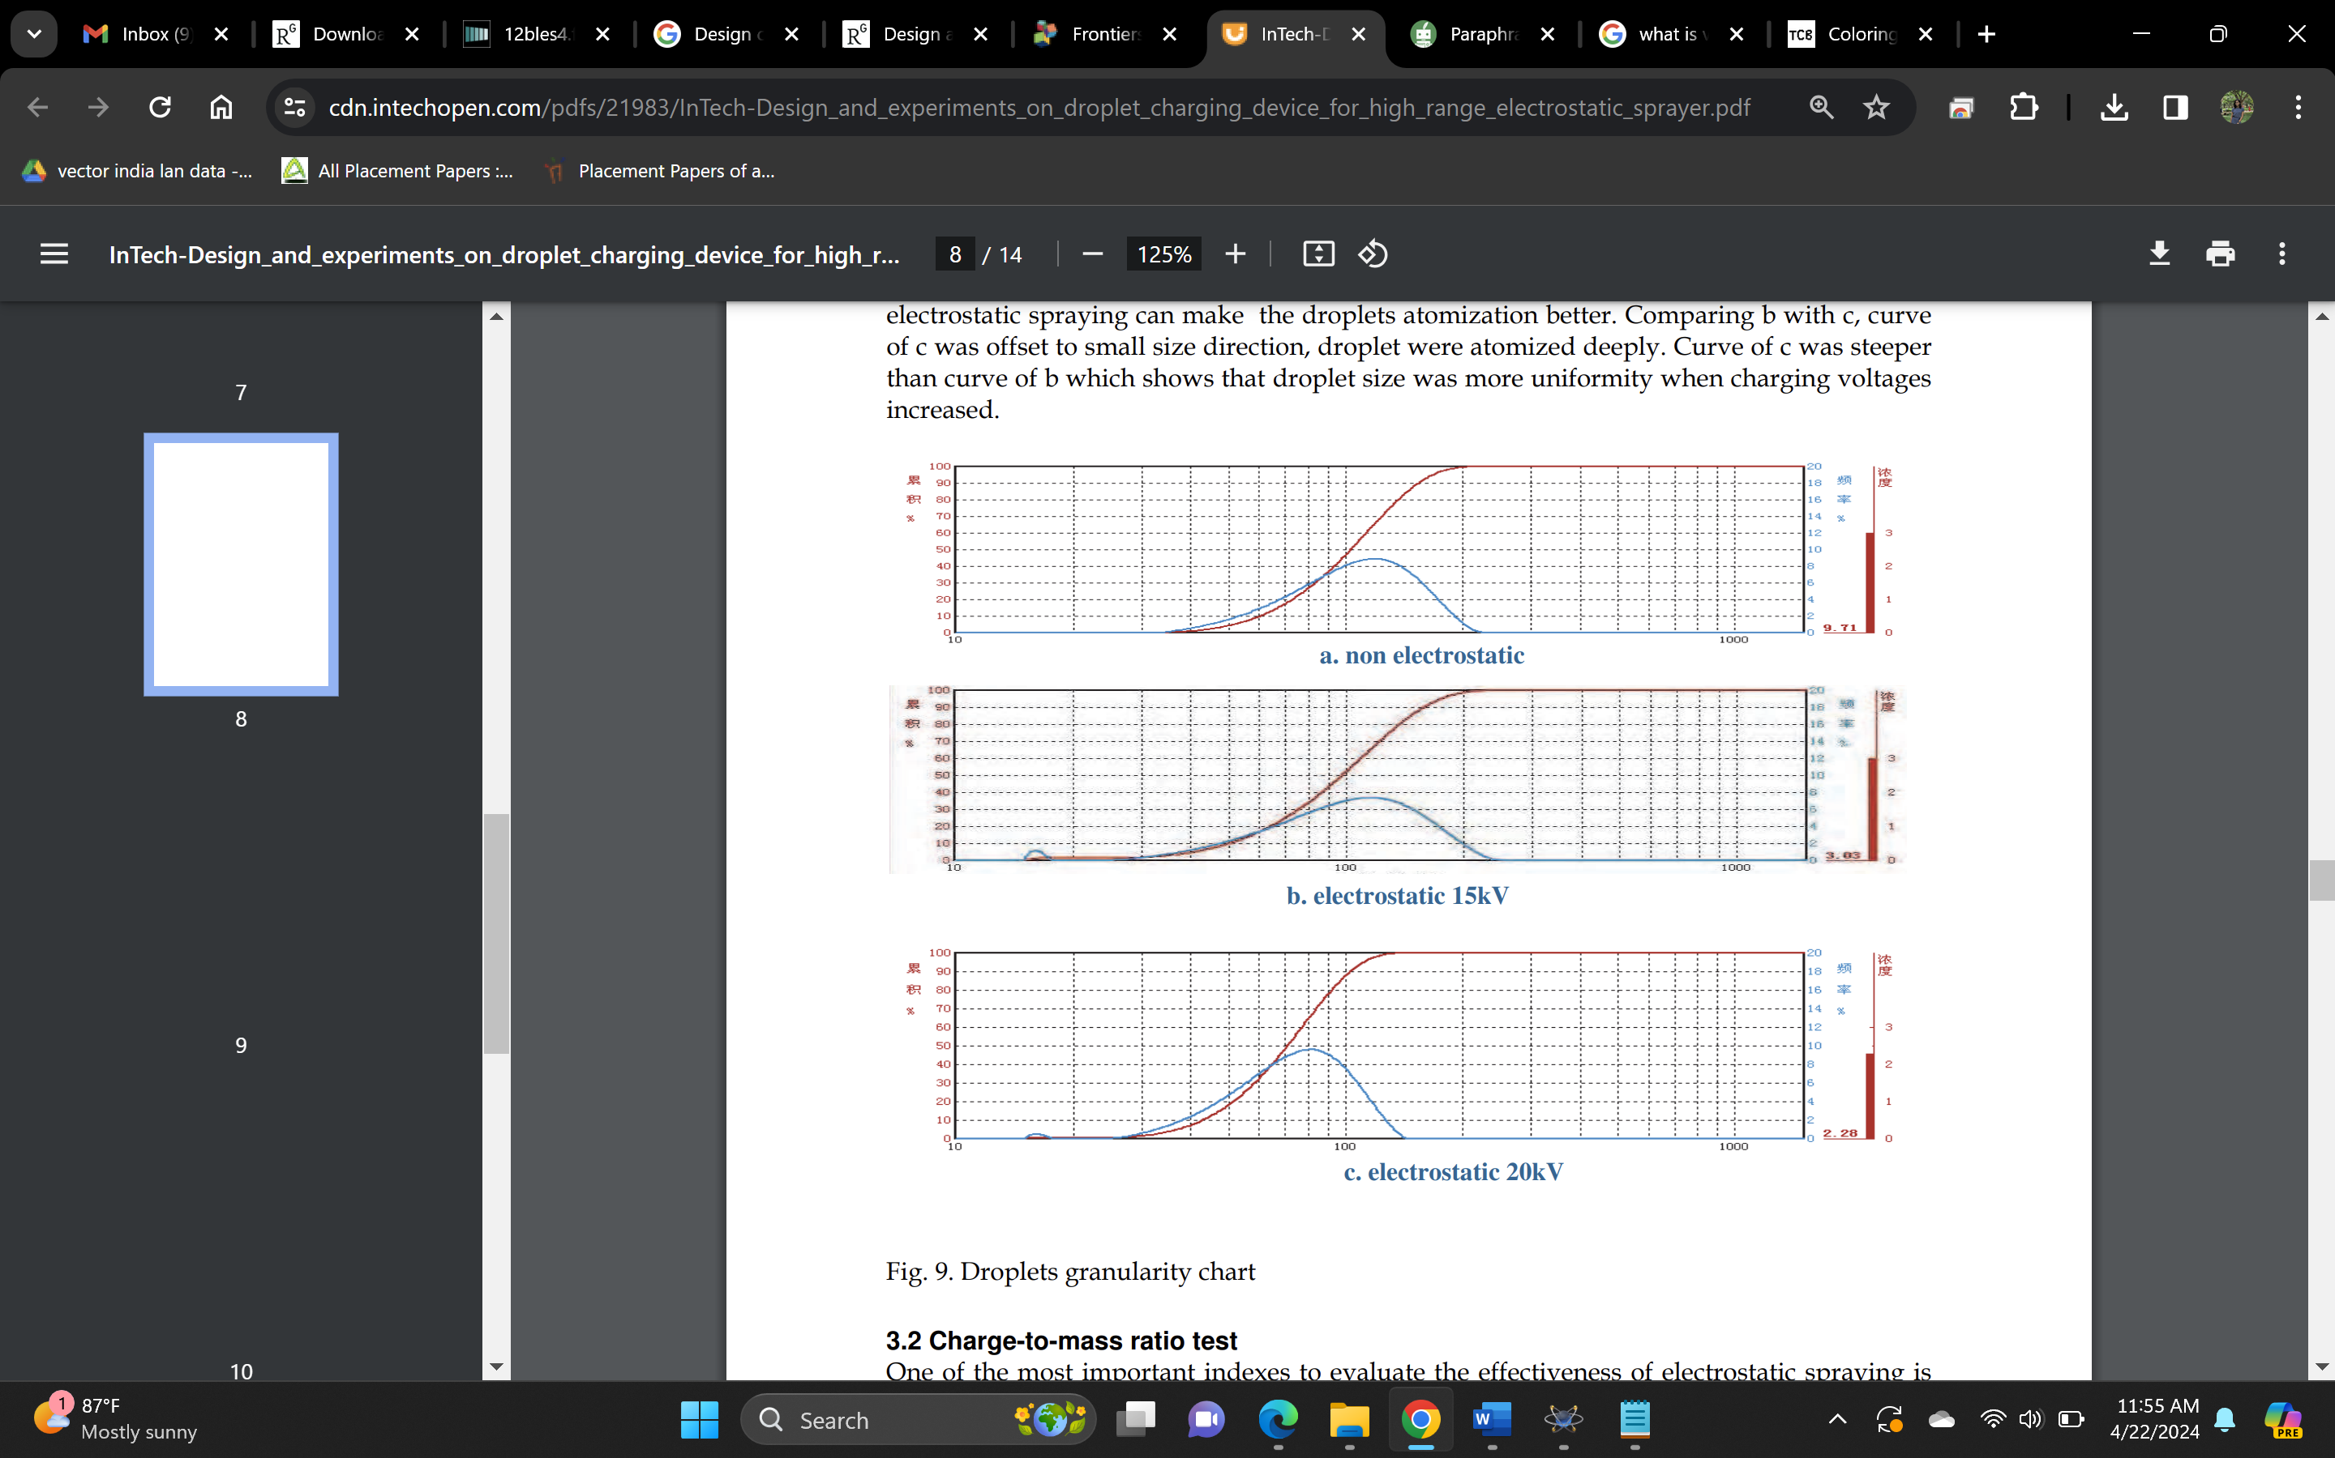

Fig. 3.4 Drop size test for various voltage

**3.3.3 Charge-to-mass ratio test**

An essential statistic for evaluating the effectiveness of electrostatic spraying is the charge-to-mass ratio. The higher the charge-to-mass ratio, the more effective electrostatic spraying should be in general.

a. Not electrostatic

b. Electrostatic 15 kV

c. Electrostatic 20 kV

The charge could be calculated by measuring the current using a micro-amperemeter, and the mass rate could be determined by gathering spray liquid for a predefined period of time. The charge-to-mass ratio, or qcm, is found by dividing the current by the mass rate.

The charge-to-mass ratio was measured under specific spraying conditions at three different distances (10 m, 20 m, and 30 m), voltages (15 kV to 25 kV).

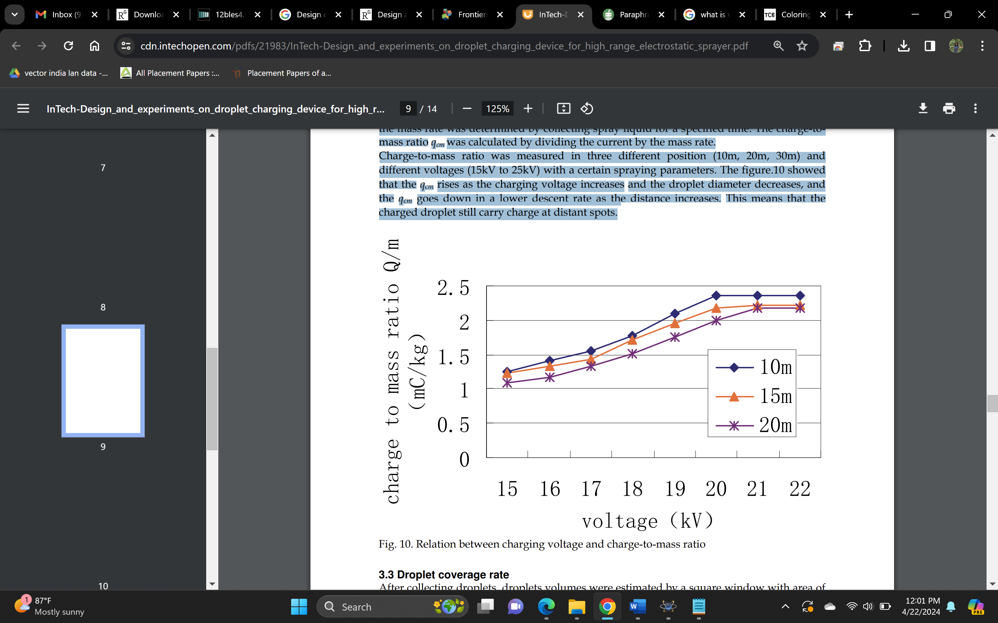

Fig. 3.5 Charge to mass ratio for various voltage

**3.4 Hardware implementation**

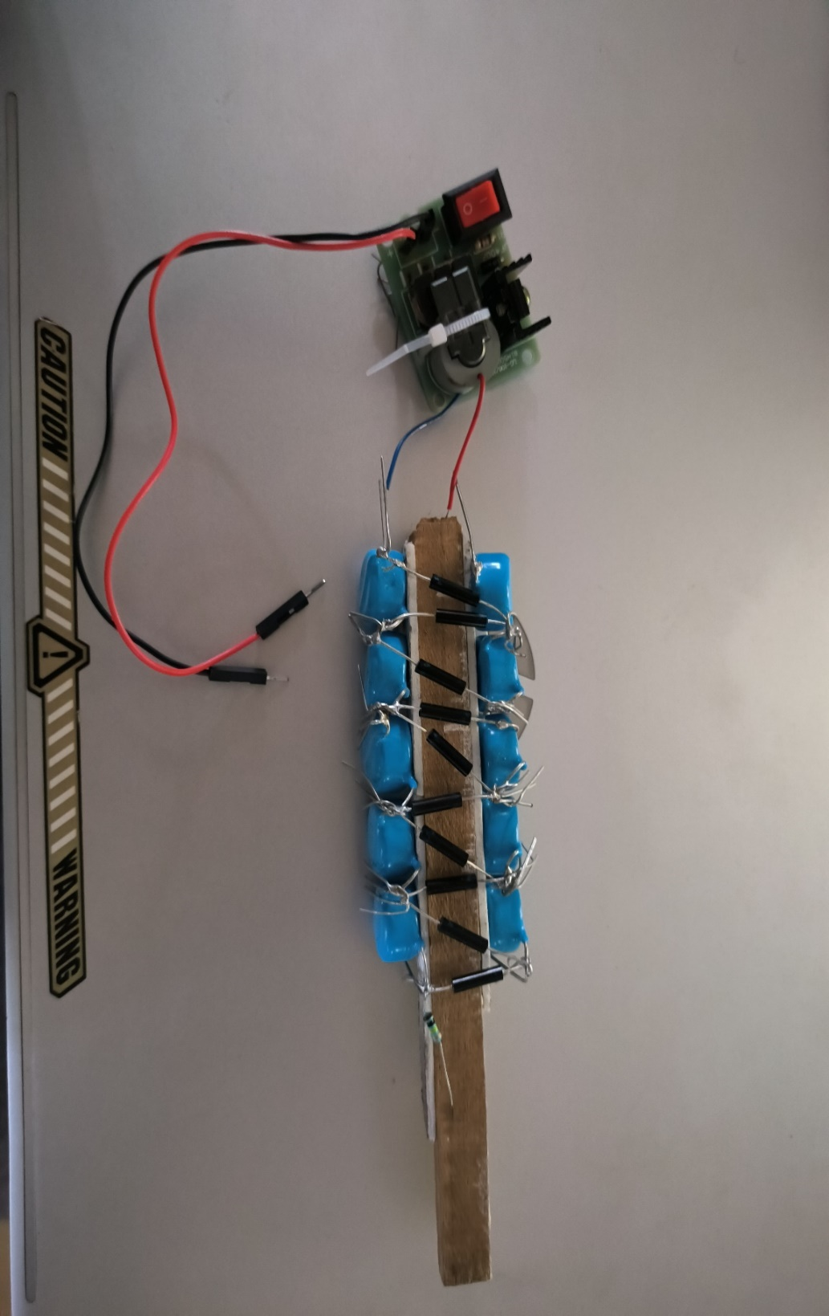

Fig. 3.6 Circuit implementation

According to above specified hardware design , figure shows the hardware implementation of voltage multiplier(cascading connection of capacitors and diodes) and DC-DC Step up transformer.



Fig. 3.7 Deployment of circuit on sprayer

As this project aims to portable Electrostatic supply, which can be applied to existing conventional system to convert it to electrostatic sraying system. Above figure shows the implementation of circuit on the conventional sprayer.

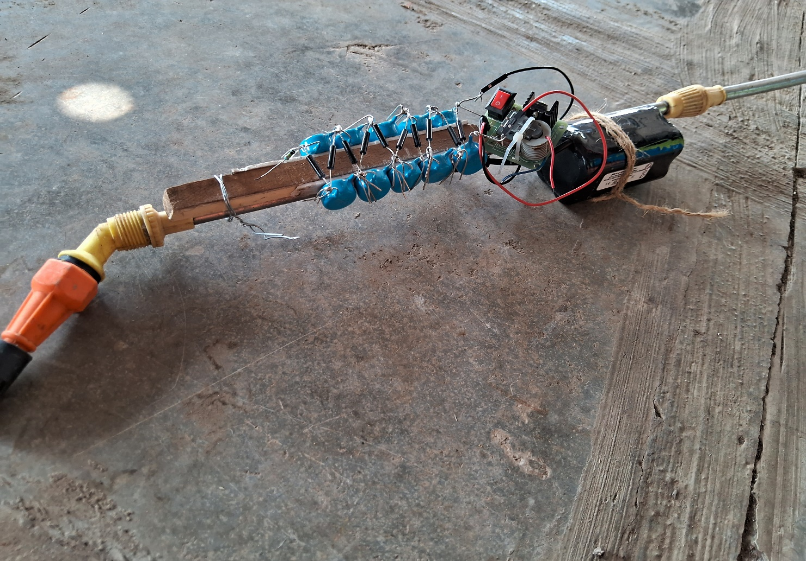

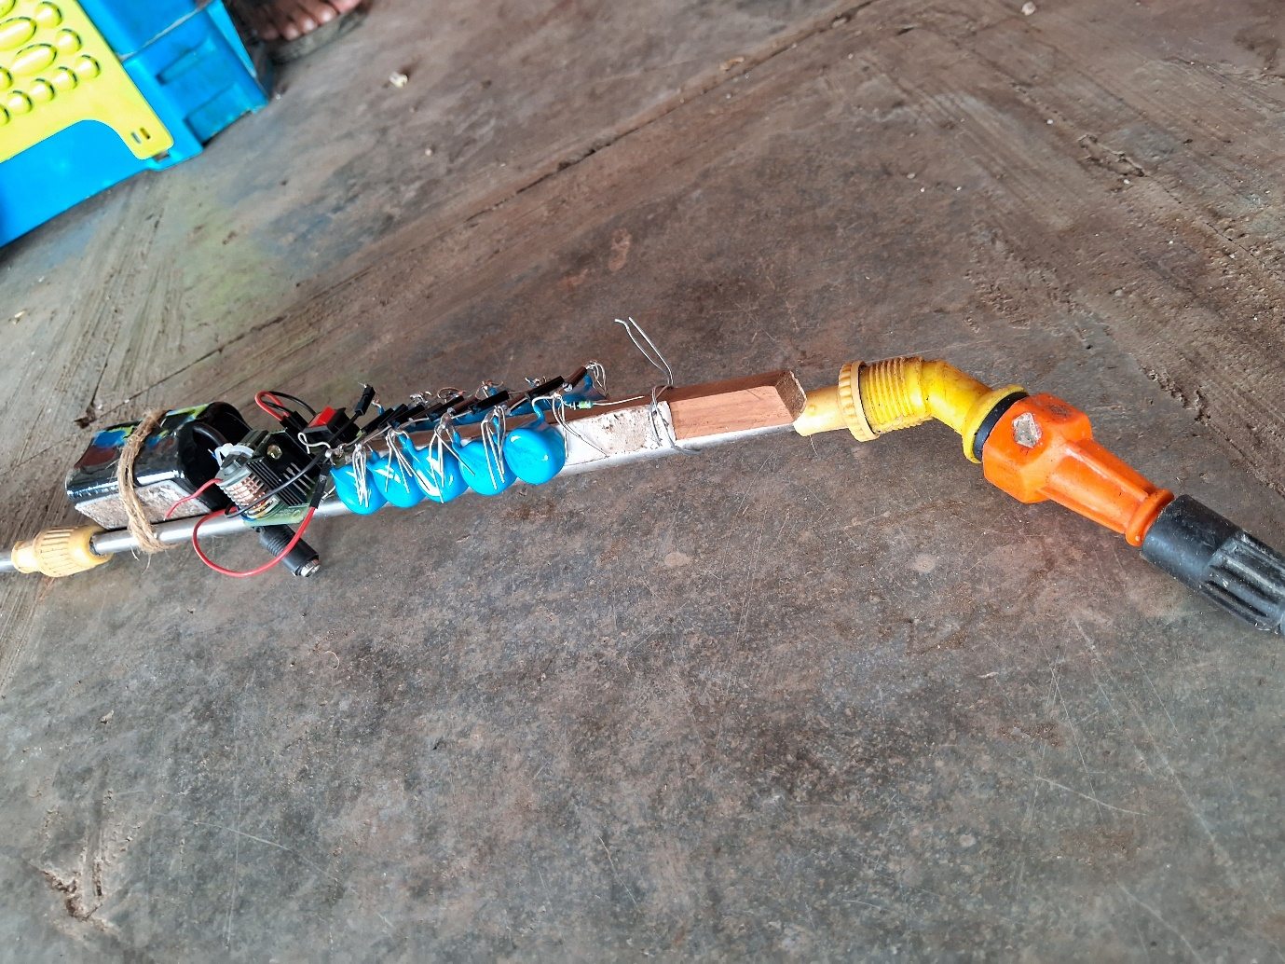

Fig. 3.8 Implementation of circuit on sprayer handle

An electrostatic electrode receives the amplified high-voltage burst that is produced. As a result, the water spray fired from a spray nozzle is charged with electrostatic supply. This implementation of providing supply to nozzle is shown in above figure.

**3.5 Software Design**

**Simulation**

* **Proteus**

Proteus is a powerful software tool widely used in the field of electronics design and simulation. Offering an integrated suite of tools for schematic capture, simulation, and PCB (Printed Circuit Board) design, Proteus enables engineers and designers to develop and test electronic circuits efficiently. One of its standout features is its comprehensive simulation capabilities, allowing users to model and analyze the behavior of both analog and digital circuits.

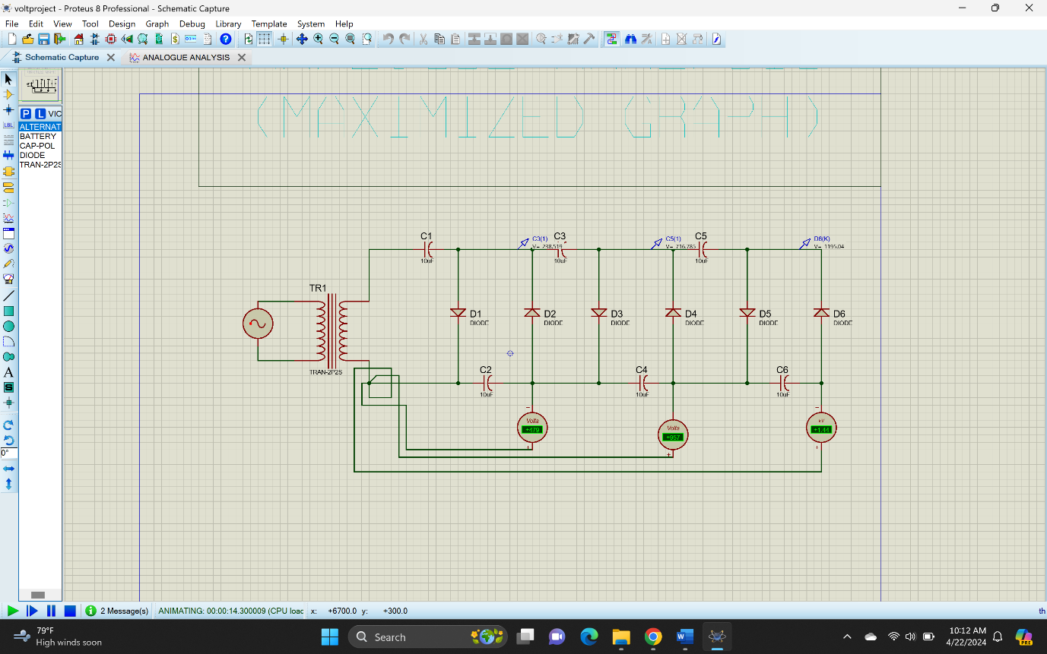

Fig. 3.9 Circuit simulation

* 1. **PCB Design and Layout**

We designed the PCB circuit using Proteus.

* The first step in designing a PCB layout in Proteus is to create a new project.
* Next, create the circuit diagram with Proteus' schematic capture tool, adding components and connecting them with wires.
* Then, switch to PCB layout by selecting “Switch to Board” from the “Design” menu, placing components, routing traces, and adding copper pours in the layout editor.
* "Routing connects components with traces, and copper pouring fills board spaces with copper. Proteus simplifies these steps with tools like the auto-router and copper pour tool.
* The last step is Design Rule Check (DRC), ensuring design meets requirements. Proteus provides a DRC tool to check for errors and warnings before exporting.
* Generated the Gerber files for PCB layout.

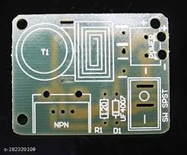

Fig. 3.10 PCB implementation

**CHAPTER 4**

**Test procedure and Results**

**4.1 Test Procedure**

In a field evaluation, the productivity and coverage abilities of electrostatic spraying systems (ESS) were evaluated against those of conventional, non-electrostatic sprayers. The goal of the study was to figure out how the two spraying techniques performed differently from one another. The field observations showed that the ESS outperformed the conventional sprayer by a considerable margin. More specifically, compared to the traditional sprayer, the ESS offered 1.5 times greater coverage. This notable difference demonstrates how much more effectively and uniformly coating ingredients can be dispersed throughout the target surface using electrostatic spraying technology. Greater adherence and distribution of the electrostatically charged particles released by the ESS led to more uniform and extensive covering. These findings highlight the potential advantages of using electrostatic spraying systems in a variety of settings where thorough and consistent coating application is required. Moreover, the observed performance advantage underscores the practical value of electrostatic spraying technology in optimizing resource utilization and achieving superior results in the field of spraying applications.

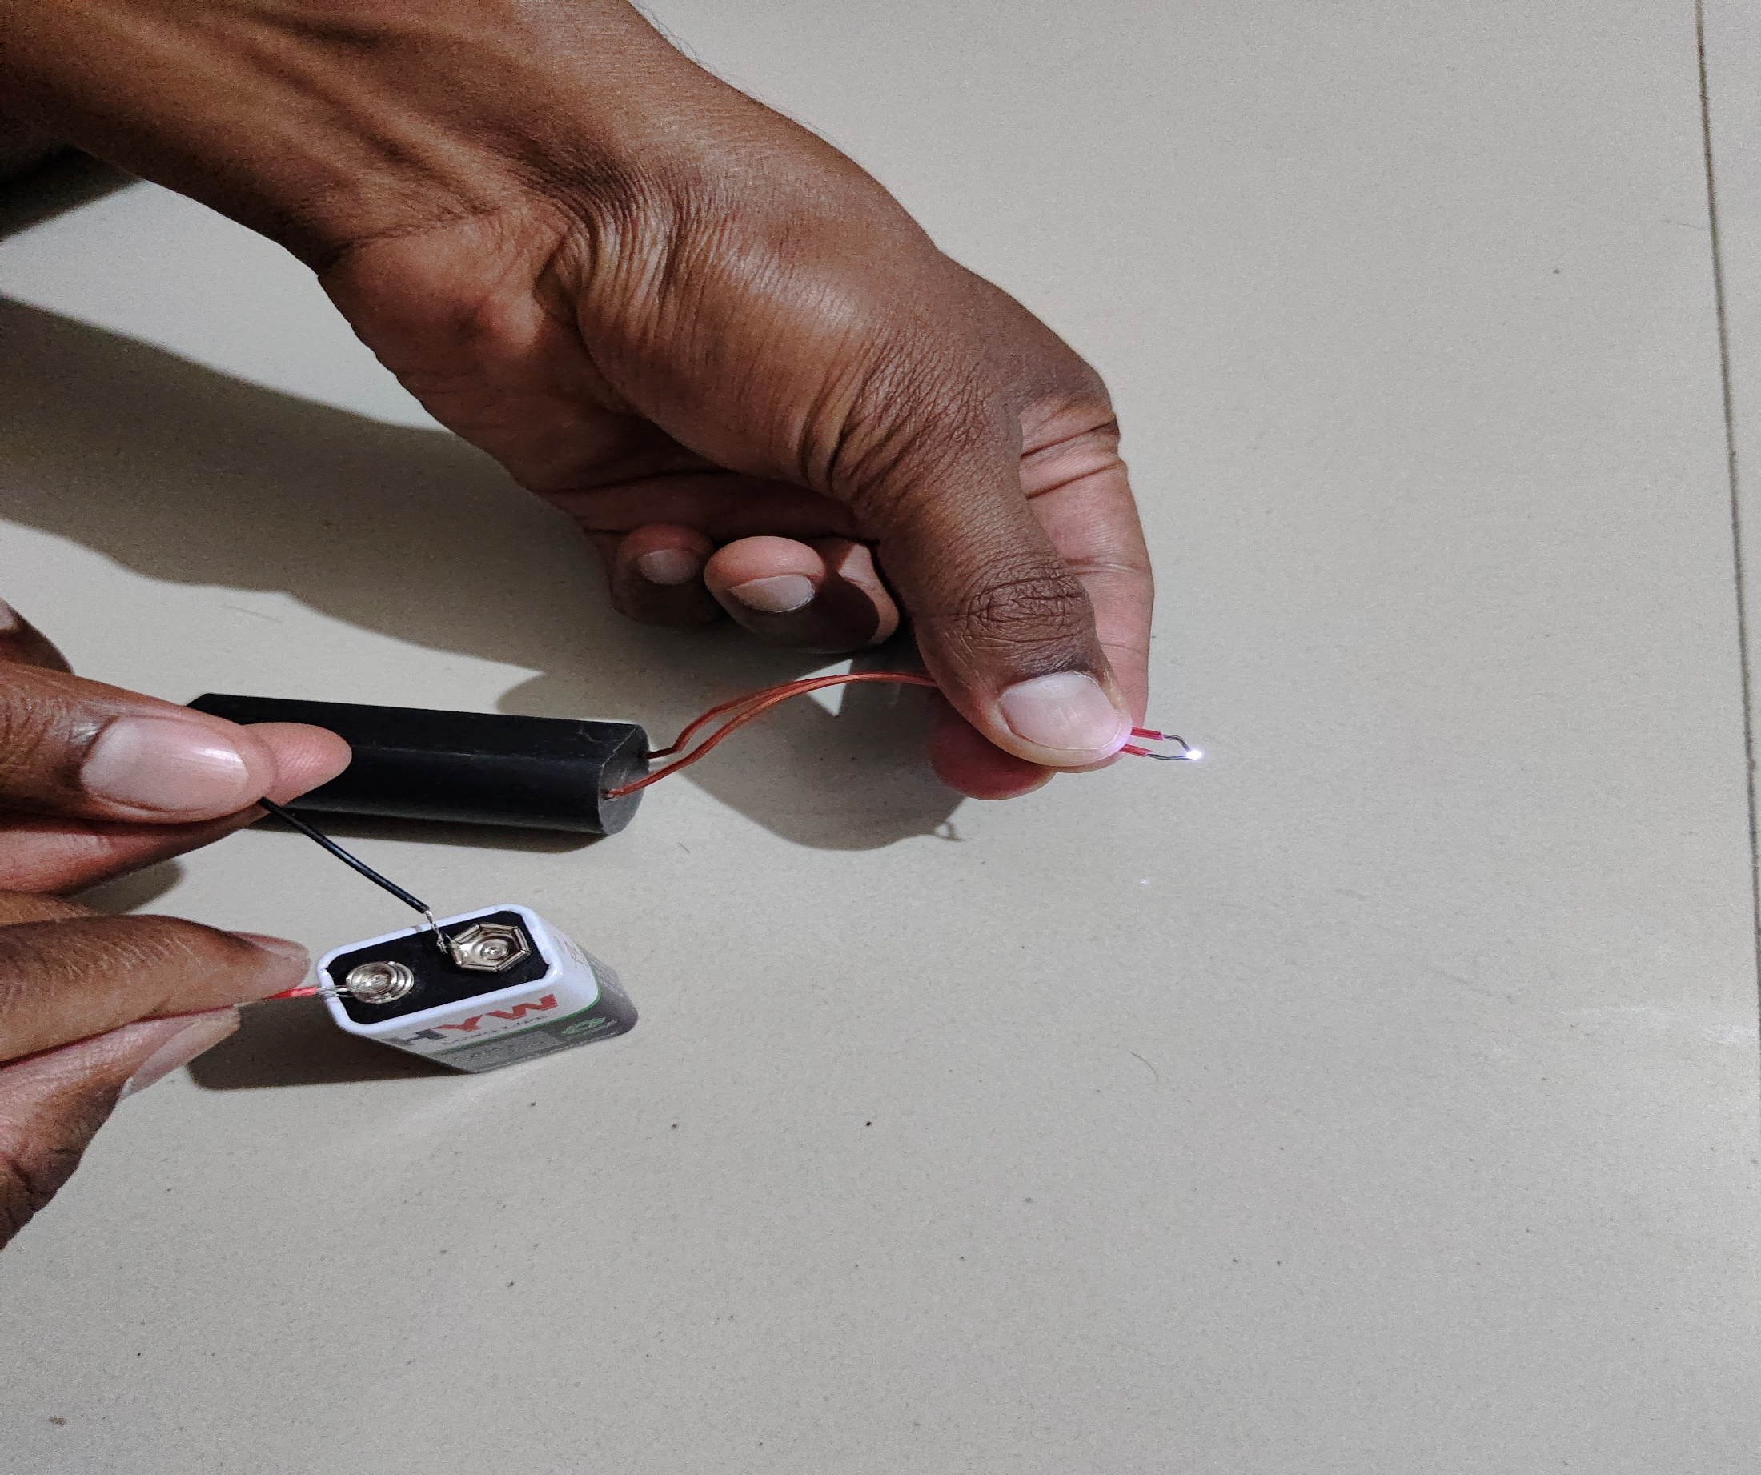

Figure 4.1 Test Result

It was clear when analysing the Electrostatic Spraying Systems' (ESS) spray pattern that it behaves like a conventional sprayer. The dispersion pattern, which encompasses the material's trajectory and spread when sprayed, seems to be comparable for both regular sprayers and ESS. The coating material is distributed evenly and consistently throughout the target surface by both techniques. The ESS uses novel electrostatic technology that charges the sprayed particles to improve adhesion, yet the overall spraying pattern is similar to that of conventional spraying techniques. This similarity in spray pattern suggests that without requiring any modifications to spraying procedures, the ESS can be easily integrated into current spraying processes and applications. Furthermore, the ESS's consistent spraying pattern demonstrates its dependability and adaptability to various spraying tasks, resulting in predictable and consistent outcomes across diverse operational settings. In essence, the ESS's comparable spraying pattern demonstrates its versatility and effectiveness as a viable alternative to traditional spraying systems, providing improved performance while retaining familiarity and ease of use.

**CHAPTER 5**

**Conclusion and Future scope**

**Conclusion**

An effective and efficient spraying application can be achieved in a variety of industries with the electrostatic spraying method. As the importance of sustainable farming rises, so does the need for technology that reduce environmental harm while protecting productivity. By decreasing the amount of chemicals used, controlling environmental damage, and improving overall pest management efficiency, electrostatic spraying systems are useful. Electrostatic spraying system improves the efficiency and reduces the work load. It also minimizes the cost and material required for spraying. An effective way to improve crop protection and maximise pesticide application is through the use of electrostatic spraying devices in agriculture. Compared to traditional spraying techniques, this technology has a number of benefits, such as better coverage on target surfaces, decreased drift, and enhanced deposition efficiency. These methods allow for more uniform pesticide application and improved adherence to plant leaves by electrostatically charging the sprayed droplets. This leads to increased efficacy and decreased environmental impact. The capacity of electrostatic spraying to charge droplets and create attraction to plant surfaces, leading to better adherence and distribution, is one of its main advantages. Conclusively, the introduction of portable electrostatic spraying systems represents a substantial development in agricultural technology, providing a flexible and effective approach to pesticide control across a range of environments. Furthermore, because of their mobility, they may be quickly deployed in response to agricultural emergencies or pest outbreaks, improving crop protection and production results.

Generally, it can be concluded that the electrostatic spraying system generates more efficient applications, increasing deposition on crops, less loss of pesticide due to wind effect , and better coverage to the both side of leaves, compared to traditional spraying system electrostatic system is most efficient.

**Future Scope**

Agriculture: The application of pesticides and crop protection could be revolutionized by electrostatic spraying. Future developments might concentrate on improved fertilizer, pesticide, and herbicide delivery, decreased drift, and precise targeting systems. AI and integrated sensors might adjust treatment rates according to crop conditions and pest activity.

Healthcare: Although disinfection is now done using it, improvements in antimicrobial treatments and more compact, portable equipment may be used in the future. In the production of pharmaceuticals, electrostatic spraying may also be used to coat tablets and capsules.

Manufacturing: By precisely applying paints, adhesives, and other coatings to surfaces, these systems can increase productivity and decrease waste. Eco-friendly coatings and robots’ integration for simplified production lines are potential future advances.

Automobile Industry: Environmentally friendly coatings and surface preparation methods for improved adhesion and durability could be improved through electrostatic painting in the vehicle production sector.

Electronics: Used in the application of conformal coatings, advancements in this field could concentrate on enhancing coatings with improved characteristics and achieving better uniformity and thickness control.

Construction: Buildings and bridges could have protective coatings applied via electrostatic spraying. Improved application methods and self-healing coatings are possible future advancement.

**References**

[1] S. E. Law, “Embedded-electrode electrostatic induction spray charging nozzle: Theoretical and engineering design,” Trans. ASAE, vol. 21, no. 6, pp. 1096–1104, 1978.

[2] M. K. Patel, H. K. Sahoo, M. K. Nayak, A. Kumar, C. Ghanshyam, and A. Kumar, “Electrostatic nozzle: New trends in agricultural pesticides spraying,” ISSN:2348 – 8379, pp. 6–11, 2015.

[3] S. E. Law, "Charging. liquid spray by electrostatic induction", Trans. ASAE, vol. 9, no. 4, pp. 501-506, 1966.

[4 S. Appah, P. Wang, M. X. Ou, C. Gong, and W. D. Jia. “Review of electrostatic system parameters, charged droplets characteristics and substrate impact behavior from pesticides spraying”, International Journal of Agricultural and Biological Engineering, vol. 12, no. 2, pp. 1–9, 2019.

[5] S. Yamane and M. Miyazaki, “Study on electrostatic pesticide spraying system for low-concentration, high-volume applications,” JARQ, vol. 51, no. 1, pp. 11–16, 2017.

[6] S. Appah, P. Wang, M. X. Ou, C. Gong, and W. D. Jia, “Electro-hydro dynamics of charge injection atomization regimes and fundamental limits”. At. Sprays, vol. 13, pp. 173–190, 2003.

[7] V. Mamidi, C. Ghanashyam, M. K. Patel, V. Reddy, and P. Kapur, “Electrostatic hand pressure swirl nozzle for small crop growers,” Int. J. Appl. Sci. Tech. Res. Excell., vol. 2, no. 2, pp. 164–168, 2012.

[8] Seong-Ho Son, Tae-Hyun Kim, Chang-Hyun Kwon, Sung-Roc Jang, Chan-Hun Yu, Hyoung-Suk Kim, "Lumped Parameter Model of Cockcroft-Walton Voltage Multiplier in Resonant Converters", 2023 11th International Conference on Power Electronics and ECCE Asia (ICPE 2023 - ECCE Asia), pp.2681-2687, 2023.

[9] Sang Hyeon Park, Jun Yang, Juan Rivas-Davila, "A Hybrid Cockcroft–Walton/Dickson Multiplier for High Voltage Generation", IEEE Transactions on Power Electronics, vol.35, no.3, pp.2714-2723, 2020.

[10] Y. Berkovich, B. Axelrod, D. Shoshani, Y. Beck, "DC-DC converter based on the bipolar boost converter and Dickson voltage multiplier", 2018 IEEE International Energy Conference (ENERGYCON), pp.1-6, 2018.

[11] Prudente, M. Pfitscher, L.L. Emmendoerfer, G.Romaneli, E.F. Gules, "Voltage Multiplier Cells Applied to Non-Isolated DC-DC Converters," Power Electronics, IEEE Transactions on, vol.23, no.2, pp.871-887, March 2008.

[12] D.K. Giles and T. C. Blewett,  “Effects of conventional and reduced-volume, charged-spray application techniques on dislodgeable foliar residue of captan on strawberries,” J. Agric. Food Chem*.*, vol.39, no. 9, pp. 1646–1651, 1991.

[13] R. C. Anantheswaran and S. E. Law, "Electrostatic precipitation of pesticide sprays onto planar targets", Trans. ASAE, vol. 24, no. 2, pp. 273-276, 1981.

[14] R. A. Coffee, "Electrodynamic spraying", London, B.C.P.C. Monograph, pp. 95-107, 1980.

[15] M. D. Lane and S. E. Law, "Transient charge transfer occuring in living plants undergoing electrostatic spraying", Trans. ASAE, vol. 25, no. 5, pp. 1148-1153, 1982.

[16] Sanghyeon Park, Jun Yang, Juan Rivas-Davila, "A Hybrid Cockcroft–Walton/Dickson Multiplier for High Voltage Generation", IEEE Transactions on Power Electronics, vol.35, no.3, pp.2714-2723, 2020.

[17] A. R. Frost and S. E. Law, "Extended flow characteristics of the embedded-electrode spray-charging nozzle", Brit. J. Agri. Engr. Res., vol. 26, pp. 79-86, 1981.